IAM TASKS:
1.Create one IAM user and assign EC2 and S3 full access roles:
Search IAM
Click Create user
Enter username → example: dev-user
Click Next
Choose Attach policies directly
Search and select these two policies:
AmazonEC2FullAccess
AmazonS3FullAccess
Click Next
Click Create user

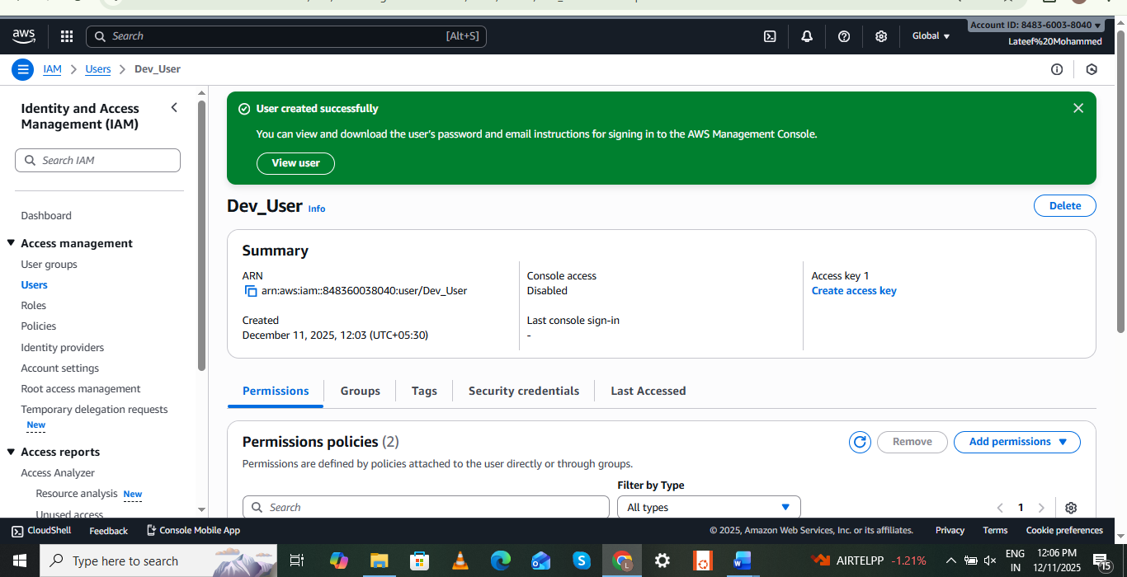

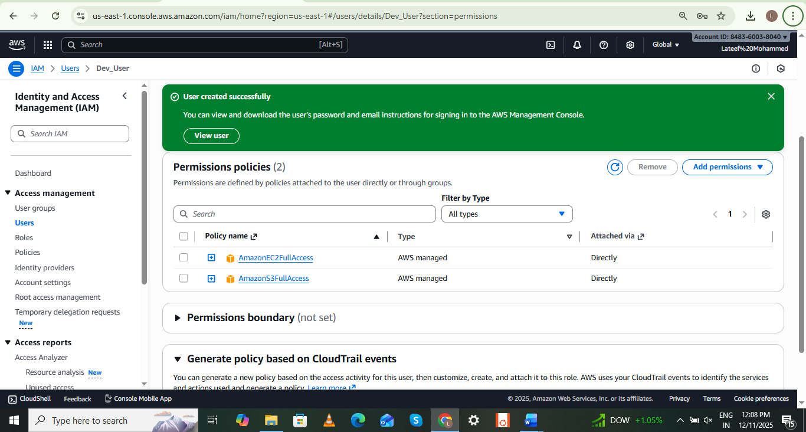

2.Create one group in IAM and assign read access for EC2:
IAM On the left side, click User groups
Click Create group.
Enter a group name — example: EC2-ReadOnly-Group.
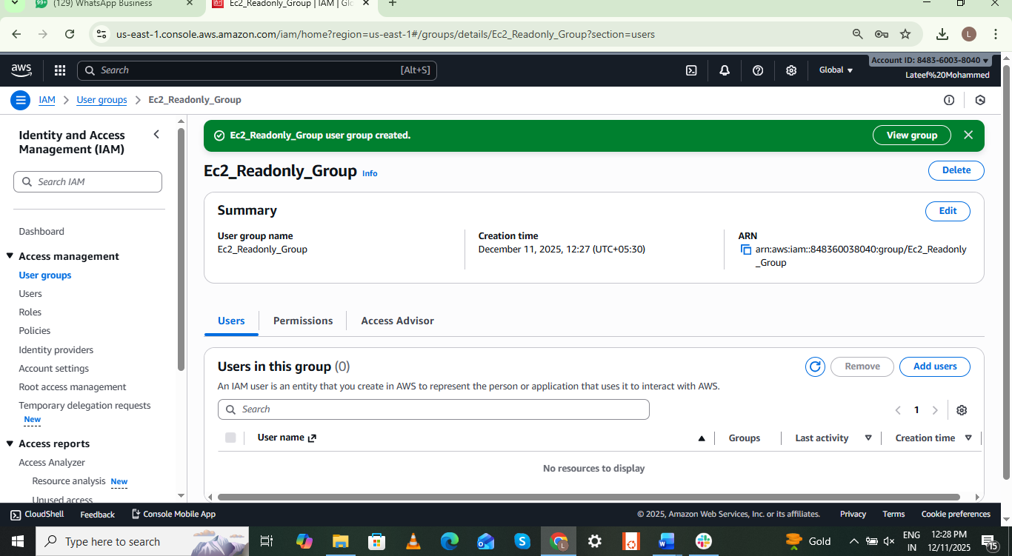
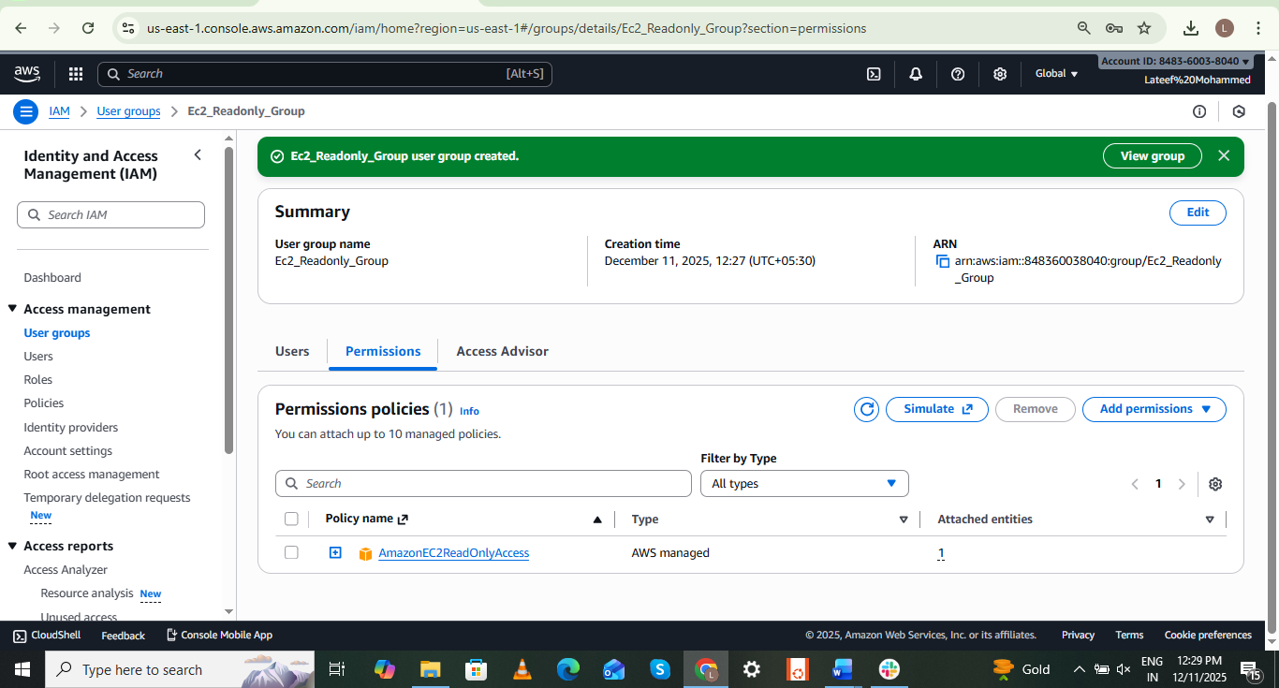

3.Create a new user named "Devops" and add to the group created in task 2:
Go to IAM → Users.
Click Create user.
Enter Username: Devops.
Click Next.
Add User to Group.
ec2-read-group.
Click Next → Create user.
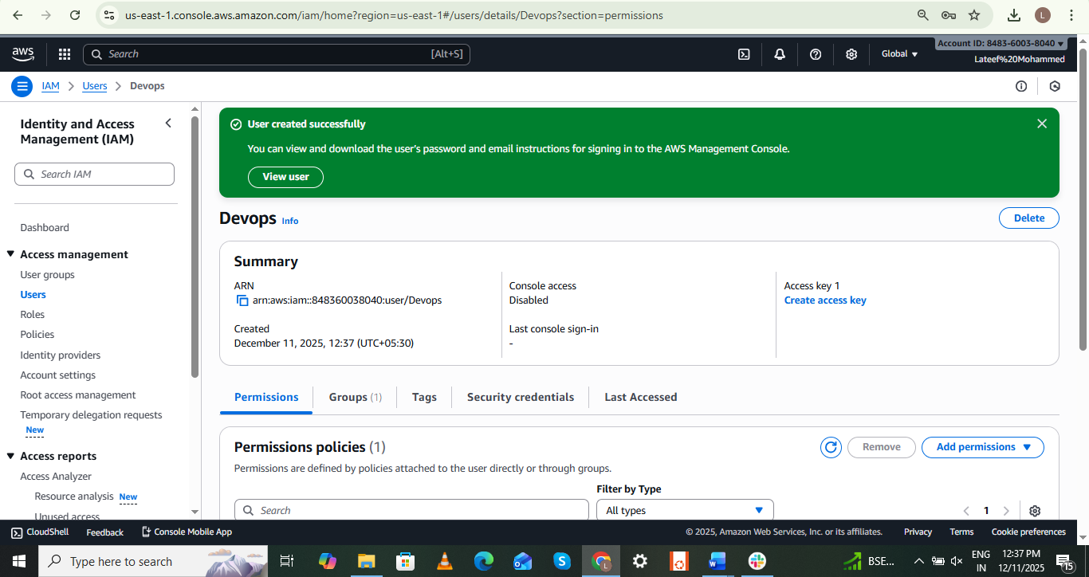
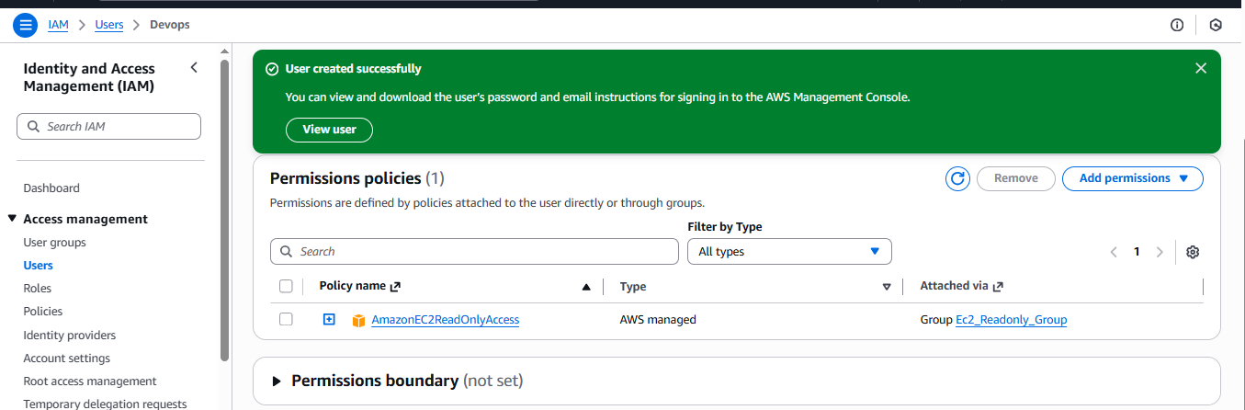

4.Write a bash script to create an IAM user with VPC full access:
Go to Aws console
Connect to the instance by using “ssh”
Generate Access key which will find in security credentials
Aws --version
Aws configure
(details )
Vi create - create-useraccess.bash
(script paste)
Chmod 755 create-useraccess.bash
./create- create-useraccess.bash
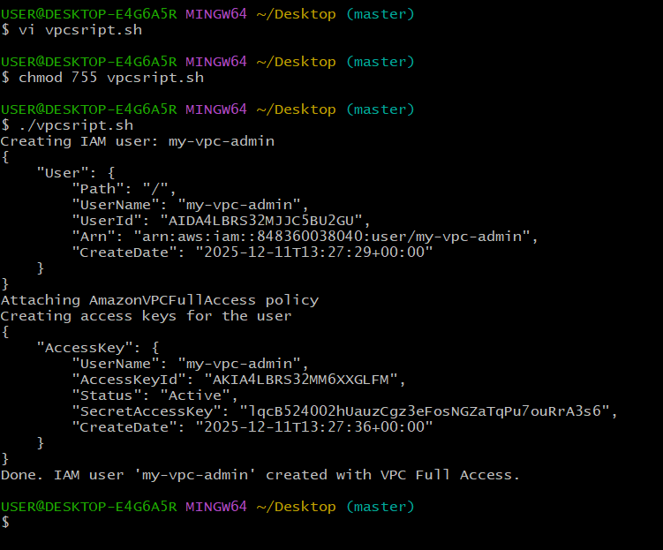

5.Create an IAM policy to allow EC2 access for a specific user in specific regions only:
Allow a specific user to use EC2
AWS Console → IAM → Policies → Create policy
Choose JSON tab
Example: EC2-Region
Policies create successfully
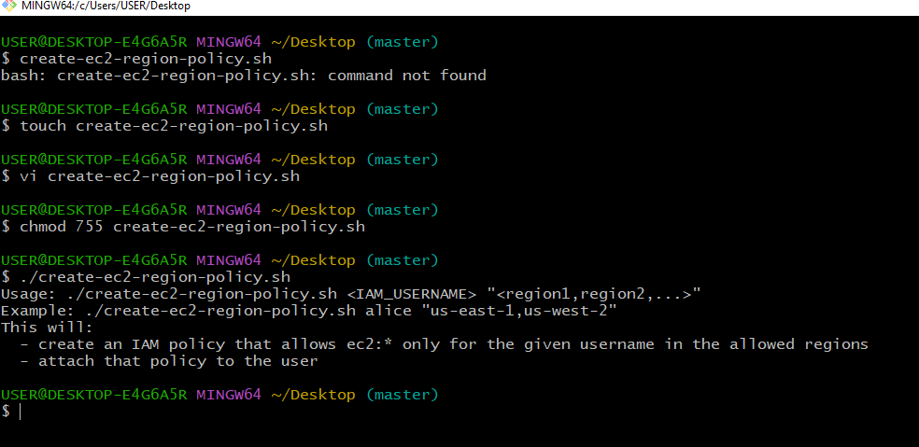
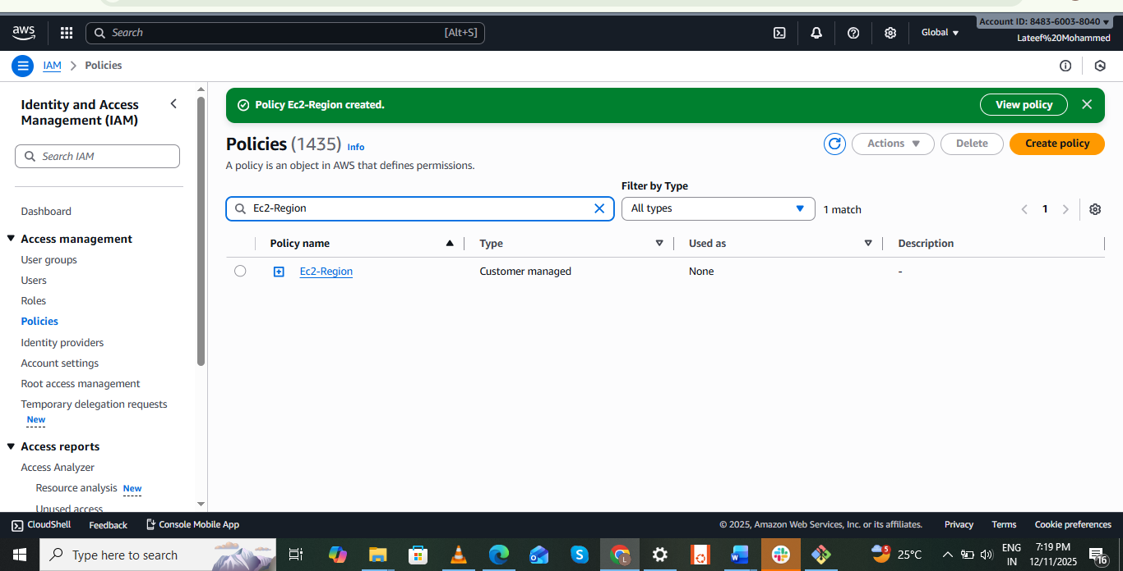

6.We have two accounts: Account A and Account B. Account A user should access an S3 bucket in Account B:
Sign in to AWS Account A
Go to IAM → Users → [Your User]
Copy the ARN. It will look like this
Add a Bucket Policy in Account B
Go to S3 → Bucket → Permissions → Bucket Policy
Replace ACCOUNT_A_ID
Replace USERNAME
Replace bucket name
Attach IAM Policy in Account A to allow S3 actions

